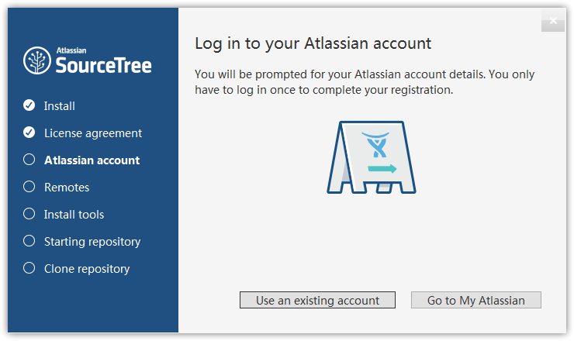

SourceTree 安装之后需要使用账号登陆以授权，以前是可以不登陆的，但是现在是强制登陆。

虽然是免费授权，但是碰上不可抗力因素，登陆不是很方便，这里记录一下跳过这个初始化的步骤。

安装之后，转到用户本地文件夹下的 SourceTree 目录，没有则新建

%LocalAppData%\Atlassian\SourceTree\

新建 accounts.json 文件

%LocalAppData%\Atlassian\SourceTree\accounts.json

输入以下内容保存即可

[ { "$id": "1", "$type": "SourceTree.Api.Host.Identity.Model.IdentityAccount, SourceTree.Api.Host.Identity", "Authenticate": true, "HostInstance": { "$id": "2", "$type": "SourceTree.Host.Atlassianaccount.AtlassianAccountInstance, SourceTree.Host.AtlassianAccount", "Host": { "$id": "3", "$type": "SourceTree.Host.Atlassianaccount.AtlassianAccountHost, SourceTree.Host.AtlassianAccount", "Id": "atlassian account" }, "BaseUrl": "https://id.atlassian.com/" }, "Credentials": { "$id": "4", "$type": "SourceTree.Model.BasicAuthCredentials, SourceTree.Api.Account", "Username": "", "Email": null }, "IsDefault": false }]

现在再打开 SourceTree，直接显示主窗口了

也可将accounts.json文件拷贝到 SourceTree 目录下